THE PROPER WAY TO WEAR A MASONIC RING
The following from Temple Topics (Illinois) is now being quoted with approval by other Masonic papers.
“What is the proper way to wear a Masonic ring? Should the points of the compass be toward or away from the body?
“If you were hanging the American flag, would you put the stars down? The same holds true of the ring. Usually it is a gift, and has sentimental value for the wearer. It should look right side up to him. Rings are therefore worn with the points of the compass toward the wearer.”
This subject is one on which Grand Lodges have made no regulation and popular opinion is divided. We must therefore reason from analogy. When the emblem of the square and compasses is displayed on a building, pennant, button, watch charm etc., universal custom requires the points of the compass point downward. When displayed on the Altar they point away from the Master. As the Master from his station views the compass from the Altar of his lodge, the points are from, not towards him. As the wearer of a compass watch charm views it, the points are down and away from his eyes. In a similar way as he views the emblem on his ring the points should be down or away from his eyes.
The square is the symbol of earthly, the compass of heavenly perfection. As a combined emblem the ends of the square point up as a symbol of man’s aspirations toward God; the points of the compass are down to represent heavenly qualities coming down from God to earth. Therefore it would seem that the proper way to wear a ring would be that is which its symbolism is best expressed; namely, that in which, when the hand is held in its usual position the points of the compass are towards the earth and away from the wearer’s eyes.
Thus it will be seen that our conclusion does not agree with the writer in Temple Topics. He truly says that in hanging an American flag we would not put the stars down, but in hanging a compass or a square and compass, he surly would put the points of the compass down. The same rule holds when worn as a ring or button or a watch charm; namely, they would be worn the same way with the points down. When so worn they all serve the same purposes, and by no means the least of these purposes is to announce to the world the proud wearer is a Mason. -- Iowa Masonic Bulletin.
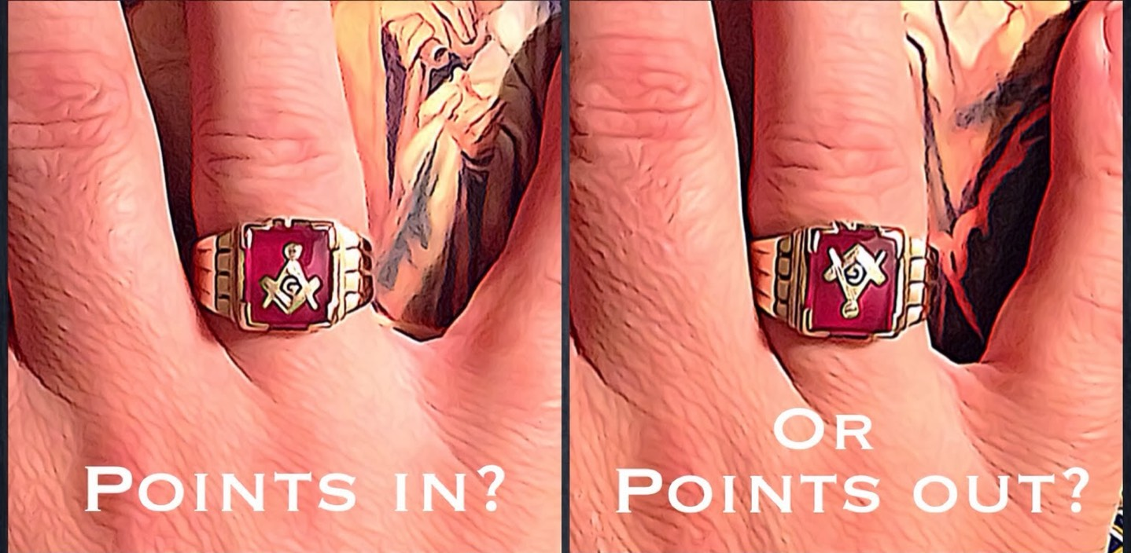

Ever since the day I became a Master Mason it was explained to me that my ring should always face me until the day comes, that I've become a past master. The points of the compass always facing to the heart as that is the way the square and compass lie on the holy book facing you when taking obligation. This is a representation of the light of masonry shining upon you. So that said, when your ring points out that is a representation of you being the master of the Lodge or a past master as then you sit on the other side of the alter giving the knowledge/light. So to solve the dilemma of the ring when your hand is placed upon that square, compass and holy book when taking obligation, is the direction that ring should point until you make past master. May the light of masonry continue to shine upon you.
Master Mason

